Sequential Function Chart Introduction

Step

Non-Descriptive Step Names

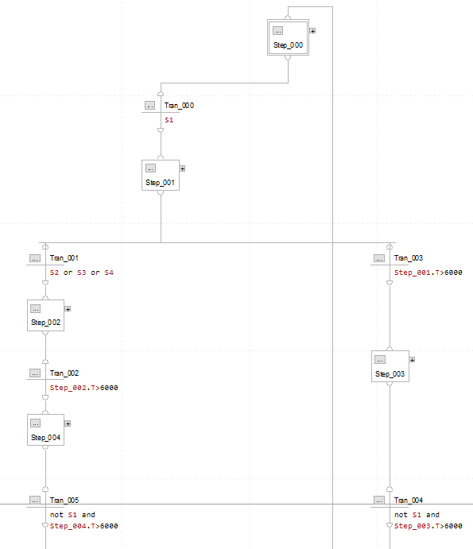

Descriptive Step Names
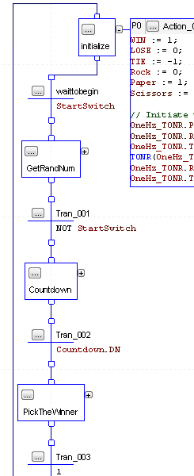

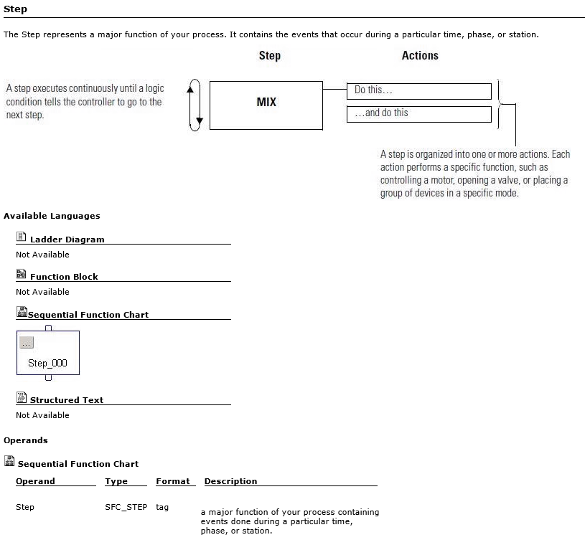

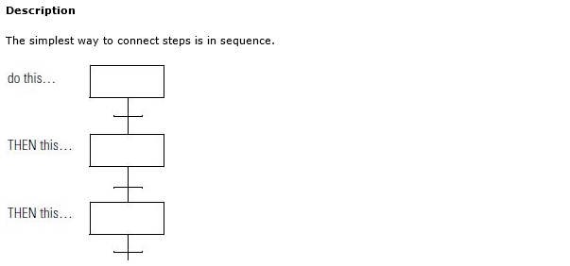

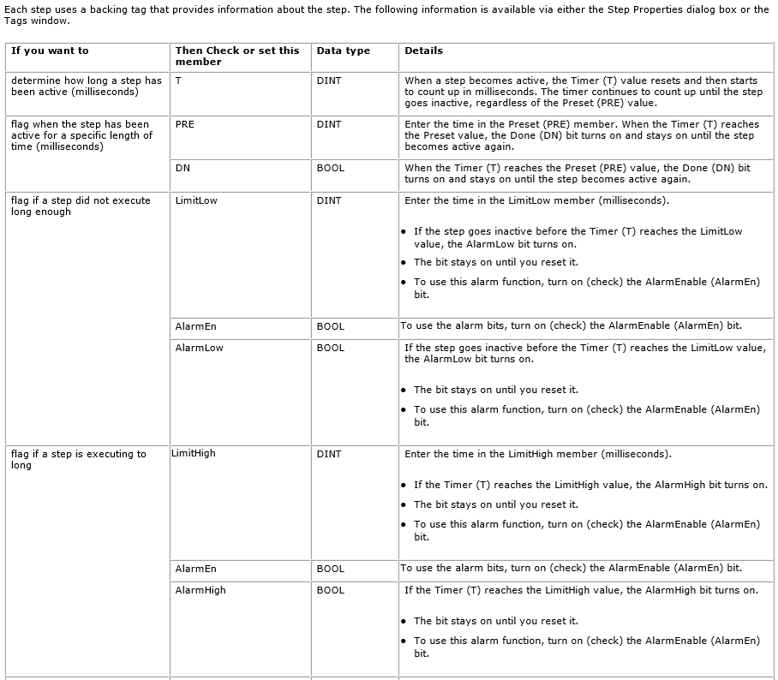

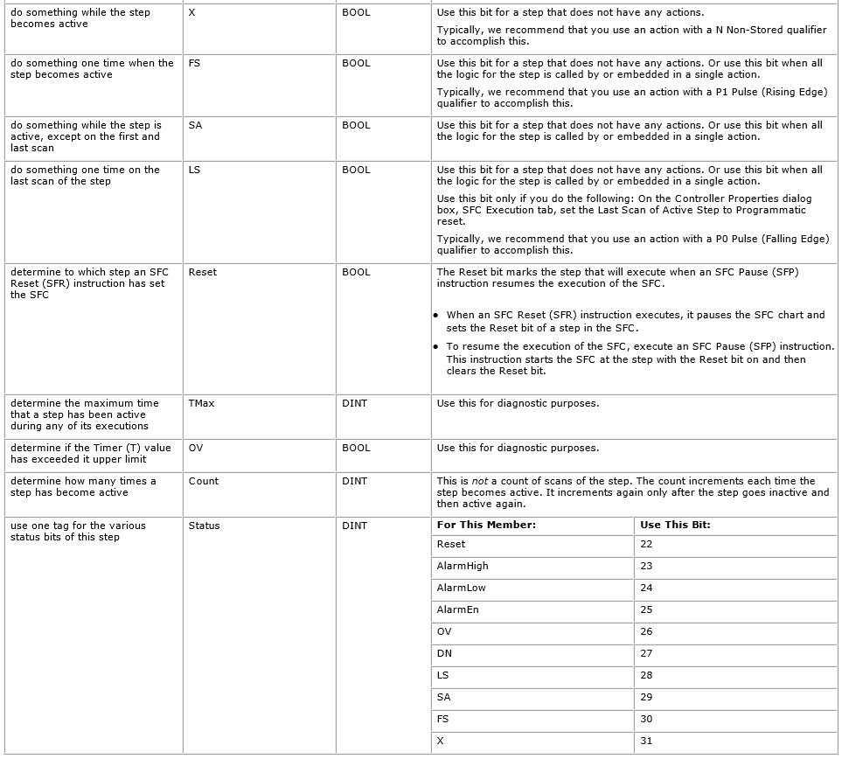

Step + Transition
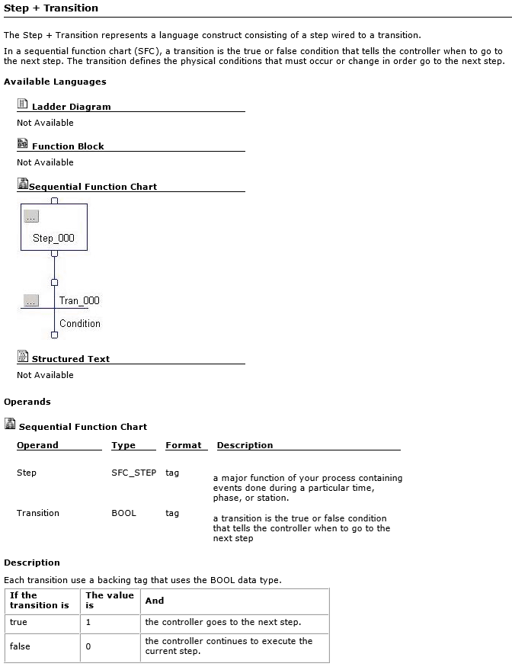

Action Qualifiers

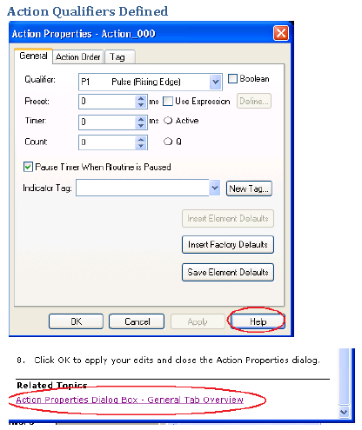

An Action Qualifier determines when an action is executed (i.e., starts and stops).
From the Qualifier pull-down menu, choose the qualifier you would like to use for this action.
P1 - Pulse (Rising Edge) | P1 – Pulse – This qualifier causes the Action to execute once when the step is first activated.
P0 - Pulse (Falling Edge) | P0 – Pulse – This qualifier causes the Action to execute once when the step is deactivated.
P - Pulse (Rising & Falling Edge) | P – Pulse – This qualifier causes the Action to execute once when the step is activated and once when the step is deactivated.
N - Non-stored | N – Non-stored – This Qualifier causes the Action to execute as long as its associated step is active. That is, it starts when the step is activated and remains active until the user moves to the next step.
L - Time Limited | L – Time Limited – This Qualifier causes the Action to start when the step is activated and to stop before the step is deactivated when the Timer count comes to an end or to stop when the step is deactivated.
D - Time Delayed | D - Time Delayed – This Qualifier causes the Action to start after a certain amount of time has transpired after the step has been activated. Moving to the next step will terminate the action whether it started or not.
S - Stored | S – Stored – This Qualifier causes the Action to start when the step is activated and remains active until a Reset action turns it off. This allows the user to continue to the next step if so desired.
SL - Stored and Time Limited | SL – Stored and Time Limited – This Qualifier causes the Action to remain active until the Timer count comes to an end or a Reset action turns it off. The action is stored allowing the user to continue to the next step if so desired.
SD - Stored and Time Delayed | SD - Stored and Time Delayed – This Qualifier causes the Action to start after a certain amount of time has transpired after the step has been activated. The action is stored and remains active until a Reset action turns it off allowing the user to continue to the next step if so desired.
DS - Delayed and Stored | DS - Delayed and Stored – This Qualifier causes the Action to start after a certain amount of time has transpired after the step has been activated. The Action will start after the delay as long as the user has not moved to the next step. If the Action does start, it will stay active until a Reset Action turns it off.
R - Reset | R – Reset – This Qualifier is used to turn off a stored action:  {S - Stored, SL - Stored and Time Limited, SD - Stored and Time Delayed, DS - Delayed and Stored}

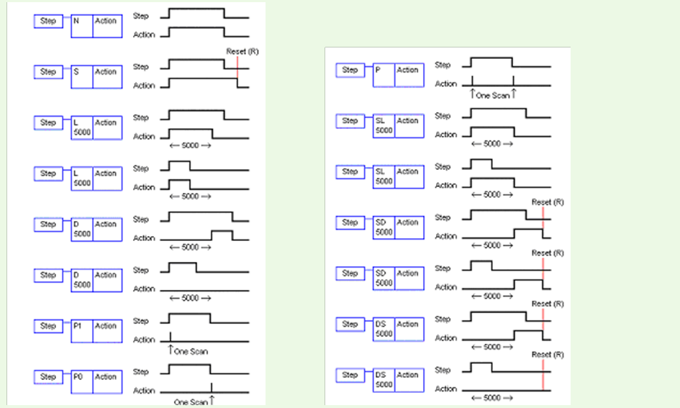

Boolean | Boolean - Check this box to designate this action as a Boolean action. A Boolean action has no body associated with it in which to program logic. This is useful when you want to have logic outside of the action monitor the status of the action (the Q bit) to make application control decisions.
Preset | Preset - The Preset is only applicable when the action uses one of the time-based qualifiers (L, D, SL, SD, DS). It is used to specify the time in one-millisecond units that the action execution will be delayed or limited, depending upon the action qualifier. This time value can be entered as an expression such that it is calculated at run time.
Use Expression | Use Expression - Checking this box allows you to specify an expression to calculate the value of the action’s preset. When this box is checked, the Define… button is enabled. Clicking on this button displays the expression editor, from which you can enter your preset expression.
Define | Define - Click this button to define the expression whose result is the Preset value.
Timer | Timer - Displays a value for the T action tag member. This is a DINT value. Use this field to monitor the time an action has been executing.
Active | Active - Displays the state of the A action tag member bit as either an On or Off value. This bit is On when the action is active.
Count | Count - Displays a value for the Count action tag member. This is a DINT value. The Count keeps track of how many times the Action has been activated since the Action Count was last reset. If this counter reaches its upper limit, it rolls over to 0 and continues counting. The Count is automatically reset when the SFC is reset.
Q | Q - Displays the state of the Q action tag member bit as either an On or Off value. If the action is a Boolean action, the Q bit is On when the action is active. If the action is Non-Boolean, the Q bit is On when the action is active, but Off during the last scan of the action.
Pause Timer When Routine is Paused | Pause Timer When Routine is Paused - This setting determines how the Action Timer reacts when the SFC routine resumes execution after being in a paused state. If this attribute is set when the SFC routine is paused, then when the SFC routine resumes execution, the timer will pick up where it was at the point of the pause. If the Action Timer is not paused, then the timer will jump forward when the SFC routine resumes execution after the pause. This is valuable for operations that consider the pause time as part of the process.
Indicator Tag | Indicator Tag - If you wish, enter a tag to be monitored in the action in the sequential function chart routine. This is optional, and is useful for tracking data values relevant to your application or the sequential function chart execution.
New Tag | New Tag - Click this button to create a tag to use for the Indicator Tag.
OK | OK - Click this button to apply your edits and close the Action Properties dialog.
Cancel | Cancel - Click this button to cancel your edits and close the Action Properties dialog.
Apply | Apply - Click this button to apply your edits and continue editing in the Action Properties dialog.
Help | Help - Click this button for help on the General tab of the Action Properties dialog.

Action Qualifier: P1 - Pulse (Rising Edge) AND P0 - Pulse (Falling Edge) Example
  - To Show the Use of P1 - Pulse (Rising Edge) AND P0 - Pulse (Falling Edge)
    - P1- Pulse (Rising Edge) – This Qualifier will cause this Action to execute once when the Step becomes active.
    - P0 – Pulse (Falling Edge) – This Qualifier will cause this Action to execute once when the Pulse falls.

  - Add a new Step and Transition pair with the following specifications:
  - Step Name: Conveyor_Alert
  - Transition Name: Conveyor_Alert_Complete
  - Add the following two Actions to the Conveyor_Alert Step:
  - Action Tag: Siren_On
  - Action Structured Text: Siren := 1;
  - Action Tag: Siren_Off
  - Action Structured Text: Siren := 0;
  - Verify that your new Step and Transition appears as follows:
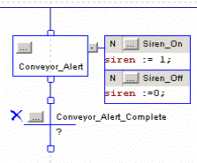
  - Click on the Conveyor_Alert Step Properties button to open its properties dialog.
  - Enter a Preset of 15000 to indicate an internal timer preset of 15 seconds (15000 milliseconds), Apply your changes, then click on OK.
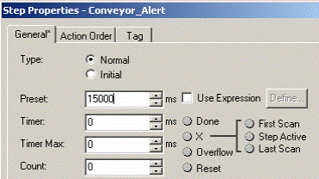
  - Click on the Action Properties button for the Siren_On Action to open its Action Properties dialog.
  - From the Qualifier pull-down menu, choose P1 Pulse(Rising Edge) as shown below:
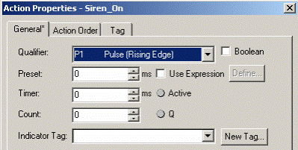
  - This Qualifier will cause this Action to execute once when the Conveyor_Alert Step becomes active.
  - Apply your change and click on OK to accept the change.
  - Using the same procedure as in the previous step, change the Action Qualifier for the Siren_Off Action to P0 Pulse(Falling Edge).
  - Verify that the Conveyor_Alert actions now appear with the P1 and P0 indicators as shown below:
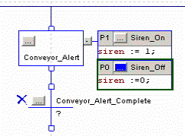

  - Add the following Structured Text as the Transition condition for the Conveyor_Alert_Complete Transition:
  - Conveyor_Alert.DN
  - Note that this is the Done bit for the internal timer of the Conveyor_Alert Step that was previously configured for 15 seconds.
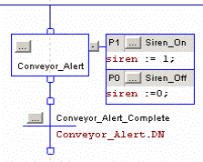

Action Qualifier: SL & R Example
  - To Show the use of SL – Stored and Time Limited AND R – Reset
  - SL (Stored and Time Limited) – This Qualifier will start the actions within this step and allow them to continue to run even if the Transition Condition is satisfied. This will allow the next step to begin while the previous step finishes its actions.
  - R (Reset) – This Qualifier will reset the stored data from the action that stored the data in the first place.

  - Add a new Step and Transition pair with the following specifications:
    - Step Name: Step_000
    - Transition Name: Tran_000
  - Add the following Action to the Step_000:
    - Action Tag: Action_000
    - Action Structured Text: Local:2:O.Data.3 := 0;
Local:2:O.Data.0 := 1;
  - Action Qualifier: SL (Stored and Time Limited)
  - Action Qualifier Time: 10000
  - Modify the Transition Condition to allow the user to use the Switches. The user will use binary knowledge to move through the steps.
    - Transition Condition: NOT Switch1 & Switch2
  - Setup the SFC to resemble the following

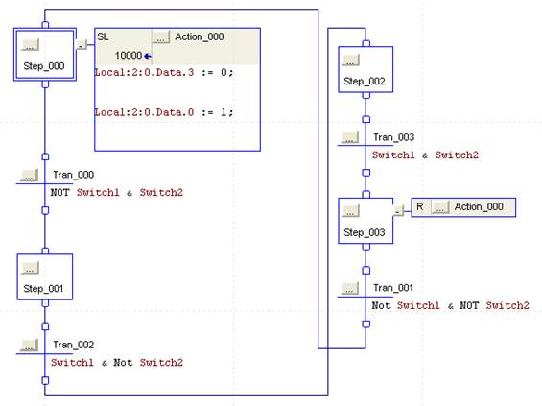
  - This Step/Transition pair will execute as follows:
  - Step_000 will execute and allow the Action to begin.
  - When the Switch1 is OFF and Switch2 is ON then the program will move to Step_001. Action_000 will continue to execute until the time has run out.
  - Flip Switch1 ON and Switch2 OFF and this will move program to Step_002.
  - Flip Switch1and Switch2 ON and this will move the program to Step_003.
  - Flip both Switches to OFF and the process will begin again.

Select Branch Diverge
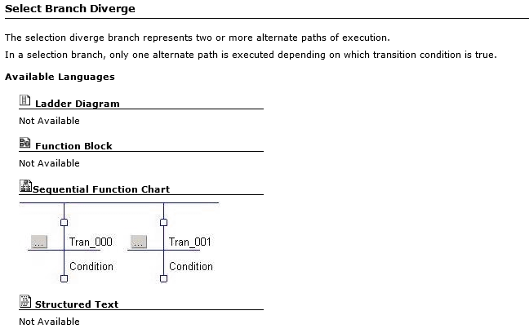
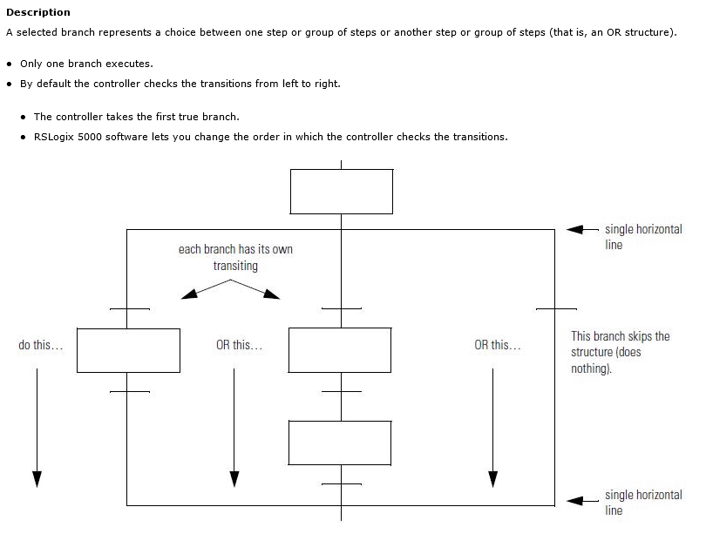

----------------------------------------------------------------------------------------------------------------------------------------------------------
Select Branch Diverge (Selects one branch to execute)

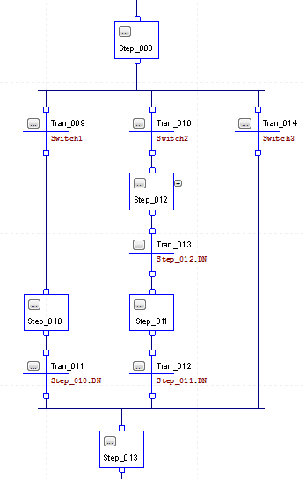

Do while wait is true:
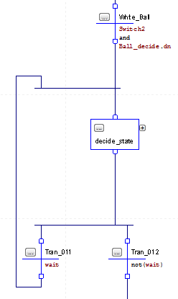

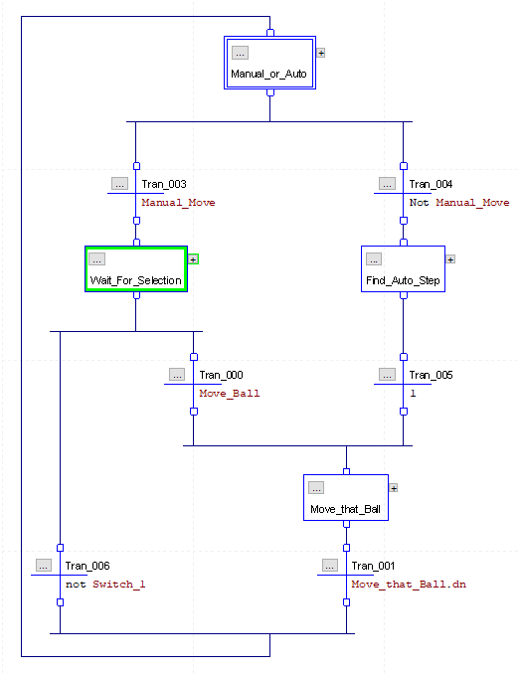

How To Create / Connect an "OR" Branch
- Connect Top of Transitions
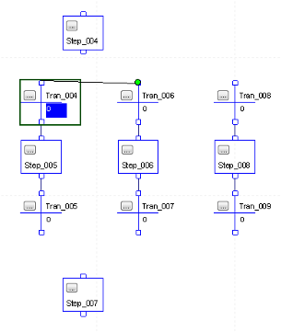
- Connect bottom step to diverge line.
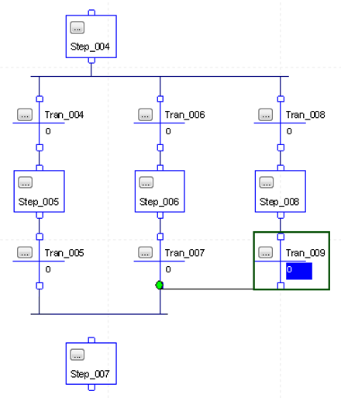
- Connect bottom of Transitions
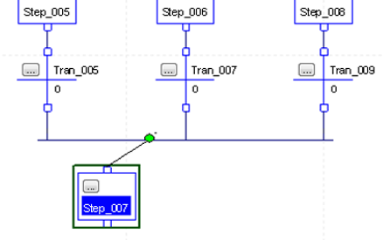

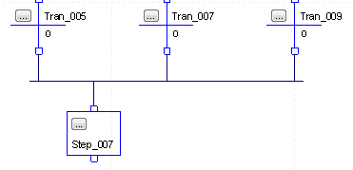
- Connect Top of Step to bottom diverge line.
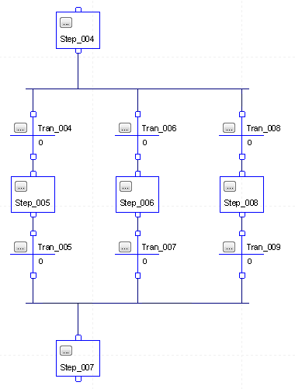

Simultaneous Branch Diverge
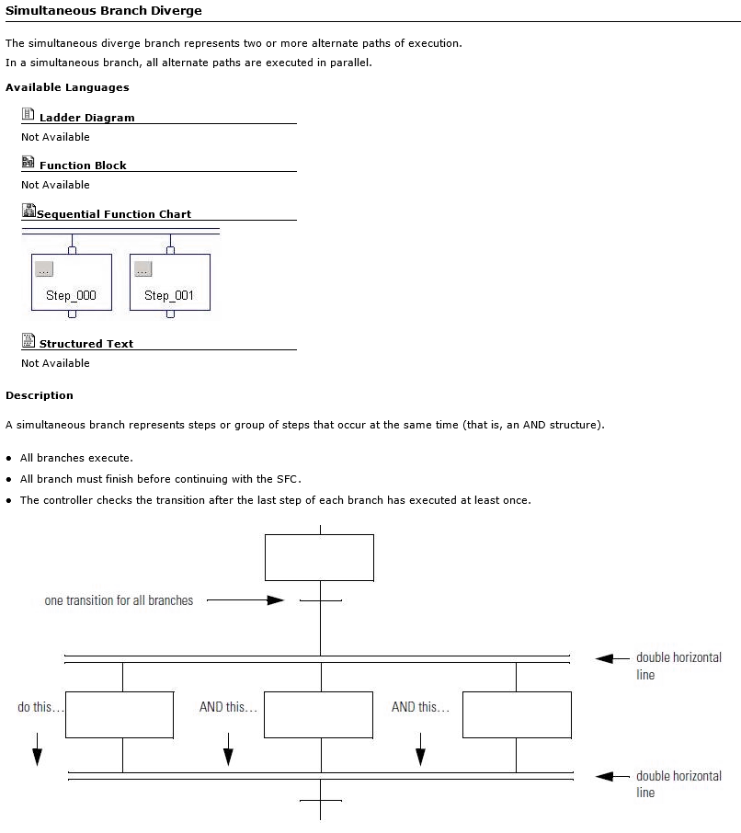
------------------------------------------------------------------------------------------------------------------------------------------------------------
Simultaneous Branch Diverge (Executes all branches simultaneously)

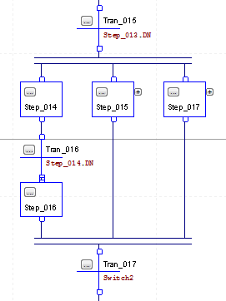

To Create an "AND" Branch:
- Connect top of Steps and then connect transition to AND Branch
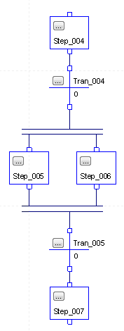
- Connect bottom of steps and then connect top of transition to bottom of AND Branch

Pause SFC (SFP)
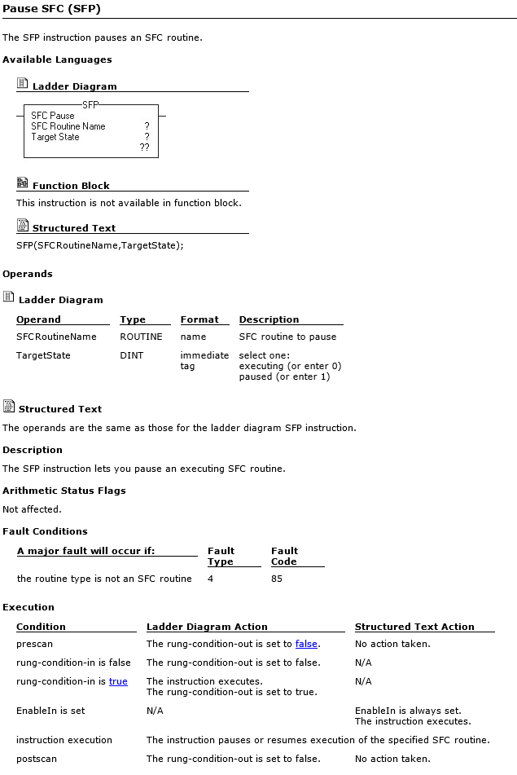

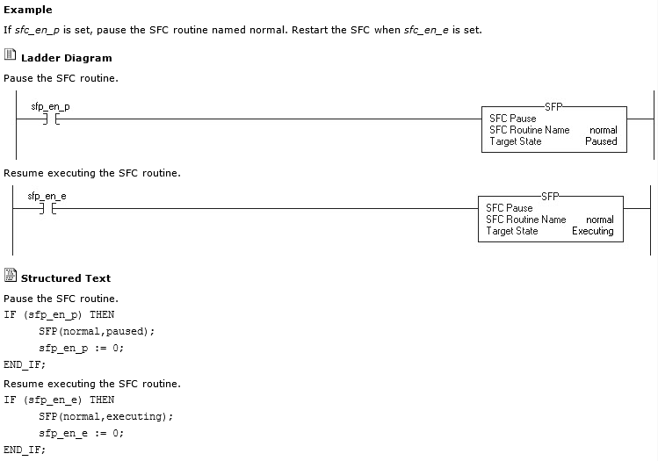

Reset SFC (SFR)
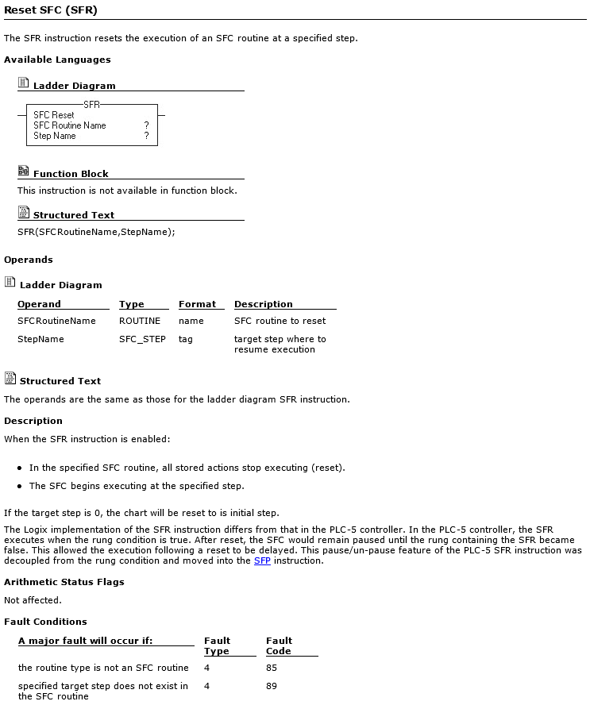

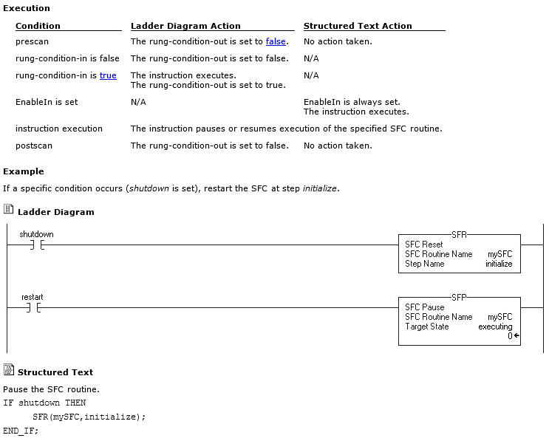

Stop
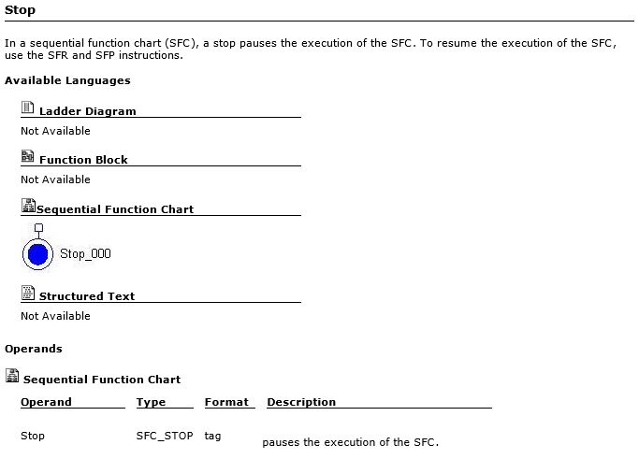

Subroutine / Return
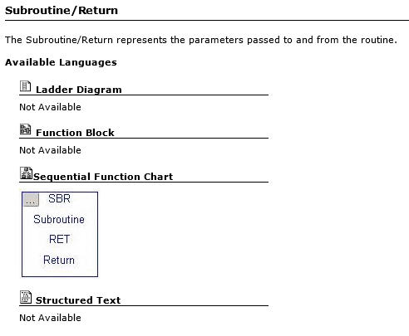

SFC: AND Branch, OR Branch, Do While, Do Initial Once

Simultaneous (AND) Branch Diverge (Executes all branches simultaneously)

Selection Branch Diverge (Selects one branch to execute)

Do while wait is true:

Do Initial Step only once
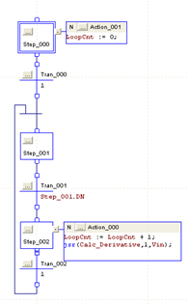

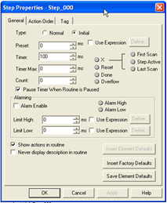

Timers

RSLogix5000 Help | Instruction Help | Contents

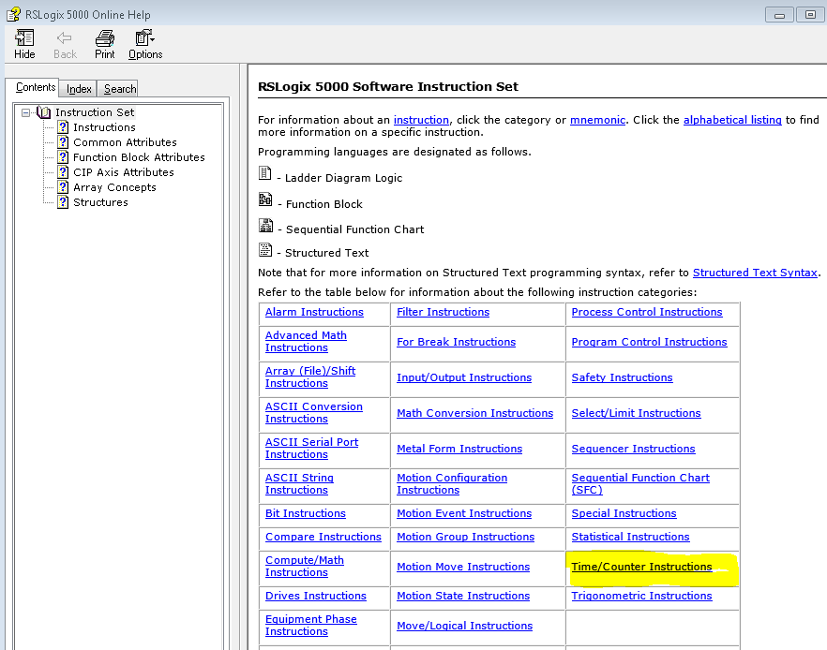

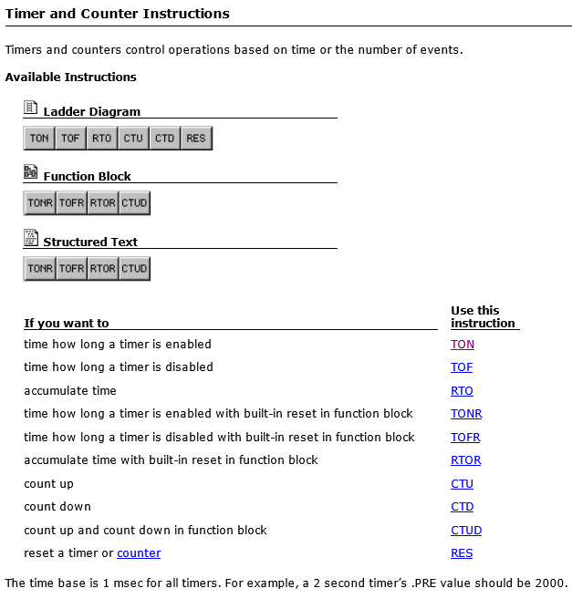

Timer On Delay (TON)
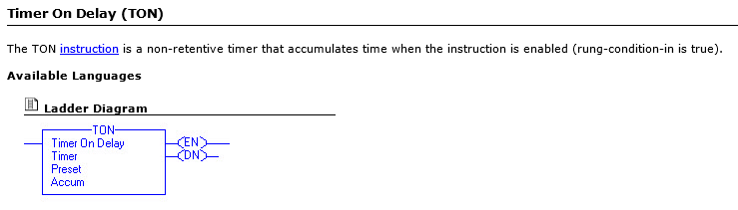

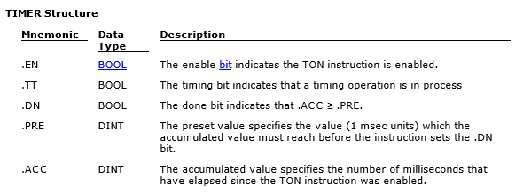

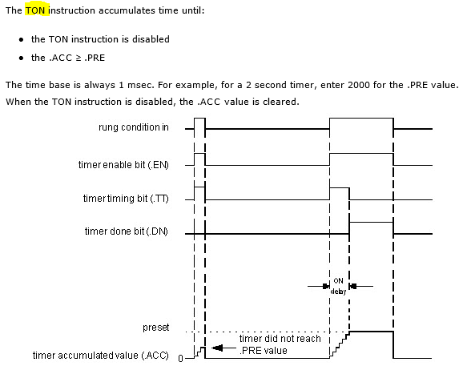

Timer Off Delay (TOF)
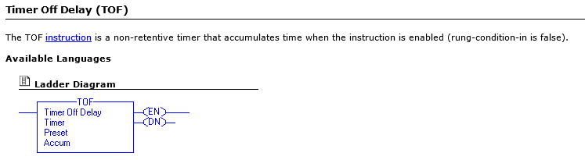

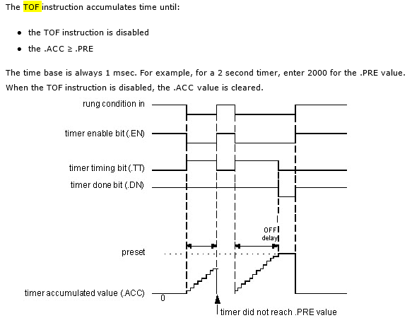

Retentive Timer On (RTO)
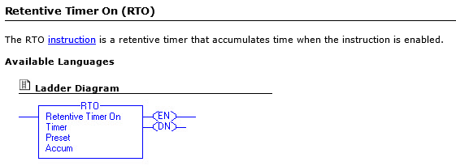

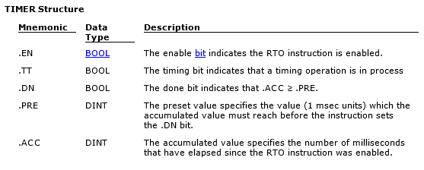
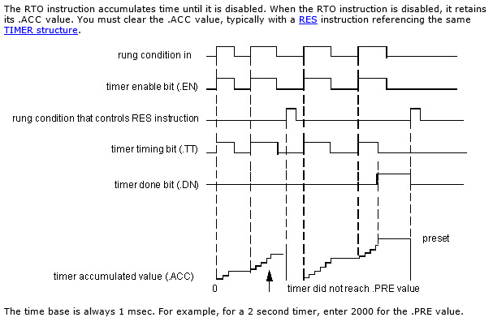

Practice: What does this do?
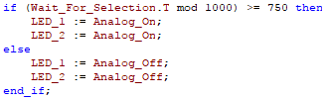

SFC Blinking LED with Step Timer

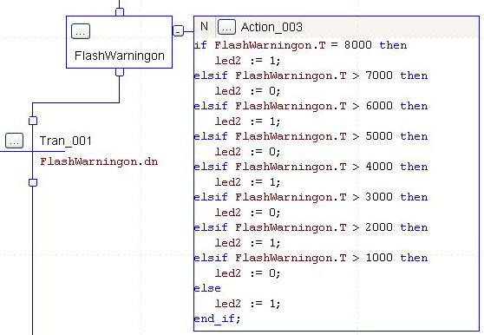

SFC Structured Text Timer
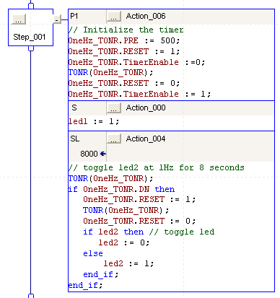

// Initialize the timer
OneHz_TONR.PRE := 500; // OneHz_TONR is type FBD_Timer
OneHz_TONR.Reset := 1;
OneHz_TONR.TimerEnable := 0;
TONR(OneHz_TONR);
OneHz_TONR.Reset := 0;
OneHz_TONR.TimerEnable := 1;

// toggle LED2 at 1 Hz
TONR(OneHz_TONR);
if OneHz_TONR.DN then
OneHz_TONR.Reset := 1;
TONR(OneHz_TONR);
OneHz_TONR.Reset := 0;
if led2 then // toggle the LED
led2 := 0;
else
led2 := 1;
end_if;
end_if;

Blink an LED with Step Timer
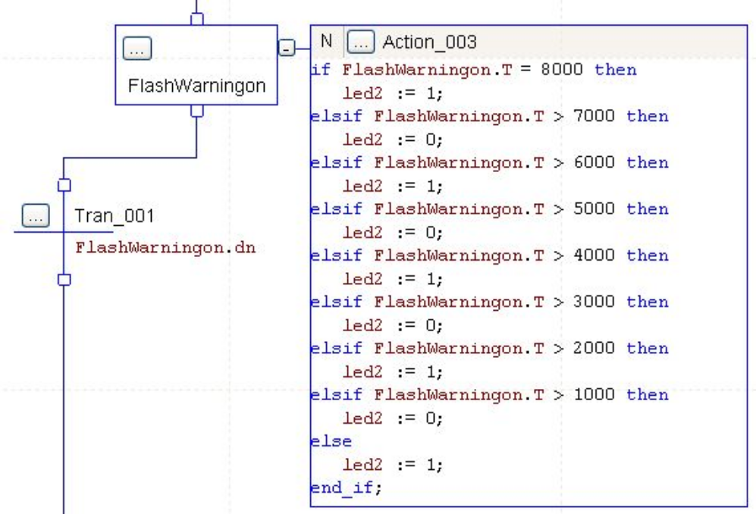

Flashing an LED

Example of two ways to flash an LED (using mod or timing bit)
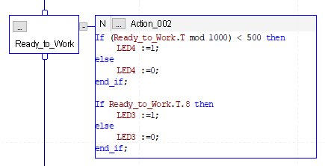

Random number Generator by running a Timer in Structured Text.
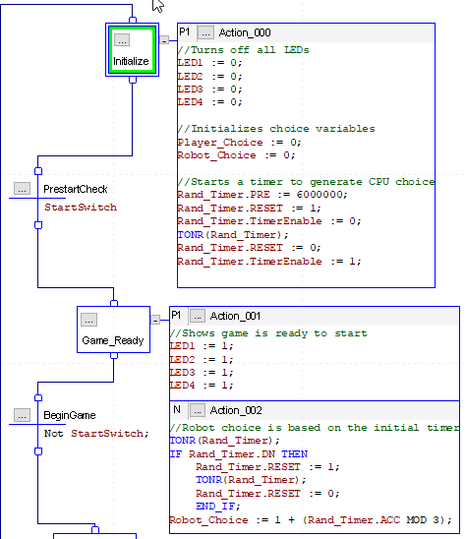

To Hide Wires
      - Right-click on a wire and select Hide Wire

Before:

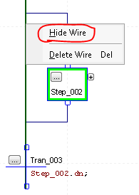

After:
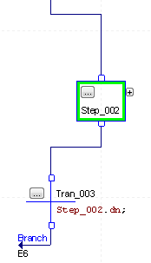

Ways To Document

Good Documentation

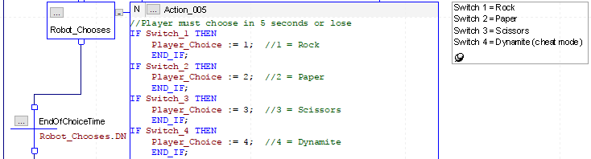

Better Documentation. Note the use of variable name to document the program.



